PROJECT DOCUMENTATION

RHYTHMIC TUNES : YOUR MELODIC COMPANION

# 1.Introduction

Project Title: Rhythmic tunes: your melodic companion

Team ID: NM2025TMID37021

# Team Leader:

Name:A.Priyadharshini& Email id:Priyadharshini78139@gmail.com

# Team Members

Name: J. Priyalakshmi& Email id:priyaspriya184@gmail.com

Name: P.Priyadharshini **&** Email id: priya97772007@gmail.com

Name:S.Priya **&** Email id:priyageetha3102006@gmail.com

# 2.Project Overview

Purpose:The purpose of this project is to create a user-friendly music application that provides rhythmic tunes for relaxation, study, and entertainment.

Features:

• Playlists based on mood and activity  
• Interactive UI with responsive design  
• Lightweight and fast performance  
• Offline support for saved tracks

# 3. Architecture

## Component Structure:

The application follows a modular component-based architecture using React.

## State Management:

Managed with Redux for global state and React hooks for local state.

## Routing:

React Router is used for seamless navigation between pages.

.

# 4. Setup Instructions

## Prerequisites:

* Node.js
* npm/yarn installed.

## Installation:

Run `npm install` in the project folder to install dependencies.

#Install server dependencies cd

../server npm install

# 5. Folder Structure

rhythmic-tunes/

│

├── frontend/

│ └── src/

│ ├── components/ # UI elements

│ ├── pages/ # full pages/screens

│ └── assets/ # CSS, images, audio

│

├── backend/

│ └── src/

│ ├── routes/ # API endpoints

│ ├── models/ # DB schemas

│ └── controllers/ # logic for routes

│

├── exports/ # final builds / outputs

├── docs/ # notes, API details

# 6. Running the Application

## Frontend:

Run `npm start` to launch the development server.

Access:Visit <https://github.com/priya123184/Rhythmic-Tunes.git>

# 7. Component Documentation

## Key Components

• Music Player  
• Playlist Manager  
• Search Bar

## Reusable Components:

• Buttons  
• Cards  
• Modal Windows

# 8. State Management

## Global State

Redux handles authentication, playlist management, and global UI states.

## Local State

Managed within individual components using React hooks.

# 9. User Interface

The UI is designed with a clean and intuitive layout, ensuring ease of use for all age groups.

# 10. Styling

## Theming

The app uses a light/dark theme toggle with styled-components for flexibility.

# 11. Testing

## Testing Strategy

Unit testing with Jest and component testing with React Testing Library.

## Code Coverage

Target of 80%+ code coverage across components and utilities.

# 12. Screenshots or Demo

Screenshots of the application UI and a live demo link will be included.

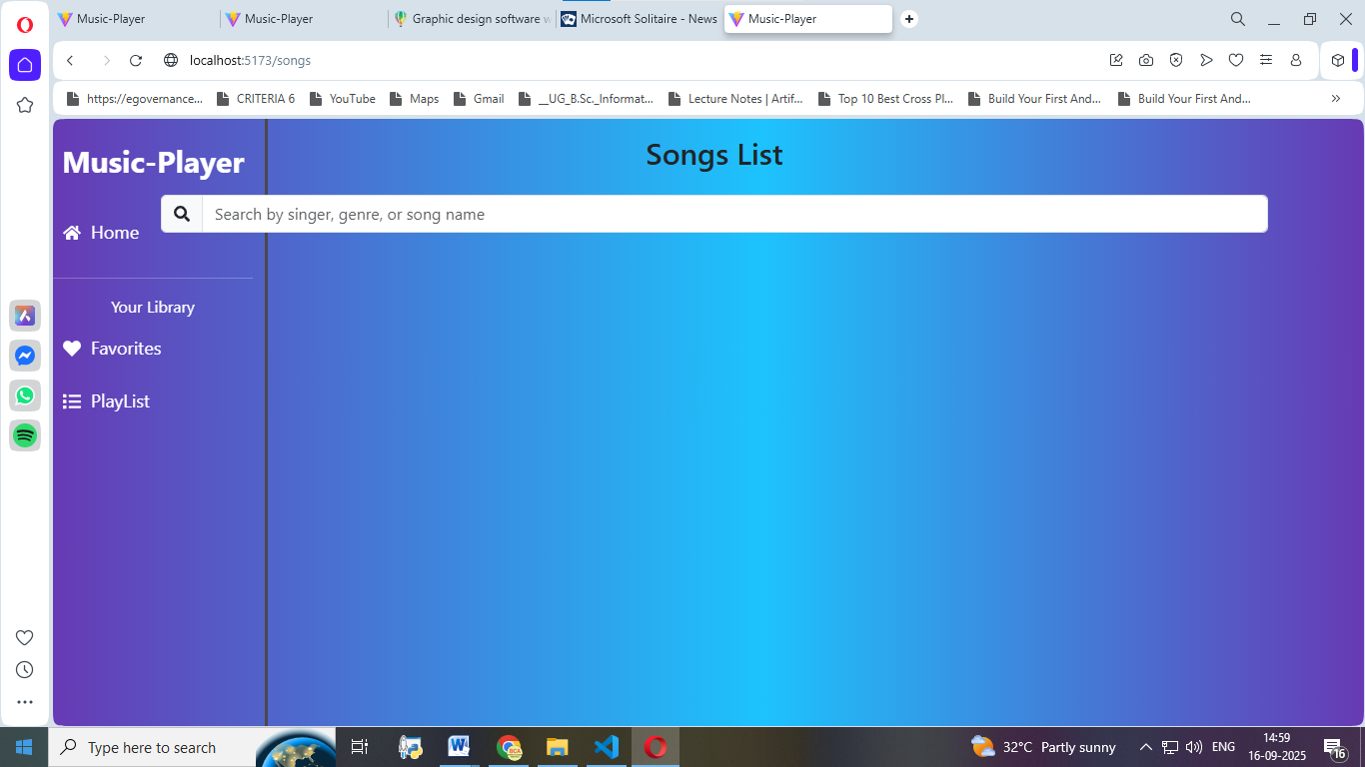

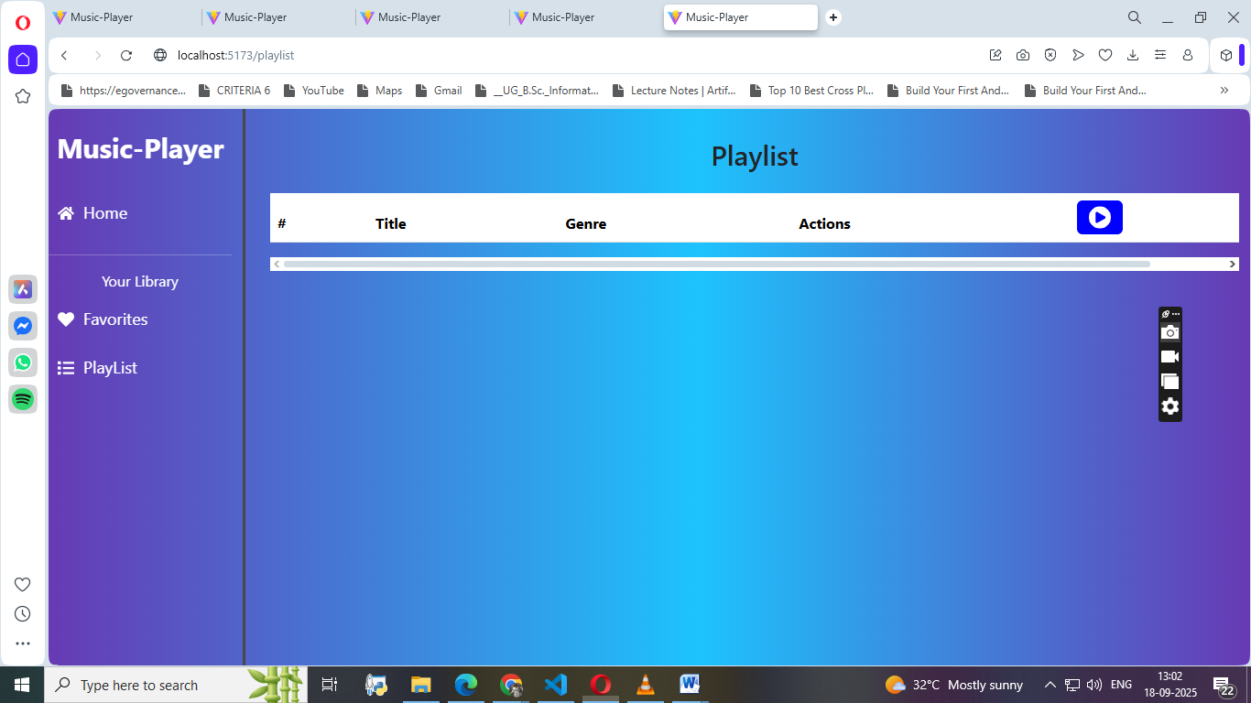

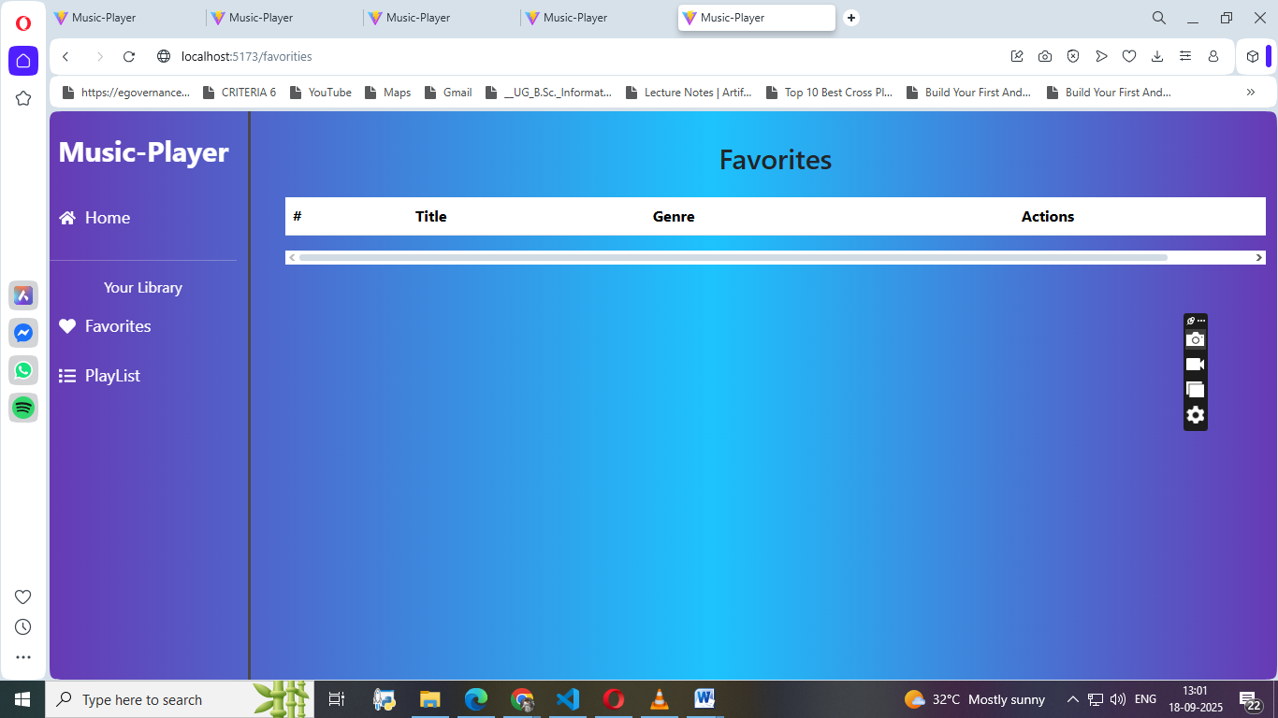

# 13. Known Issues

• Limited offline support  
• Occasional sync issues with playlists

# 14. Future Enhancements

• AI-based playlist recommendations  
• Cross-platform support  
• Enhanced offline features

# Conclusion

Rhythamic Tunes is designed to be a versatile, user-friendly music companion. With future enhancements, it aims to provide an even richer and more personalized music experience.